BIT502 Fundamentals of Programming
Assessment 3

Thomas Bernard
Student ID: 5142644

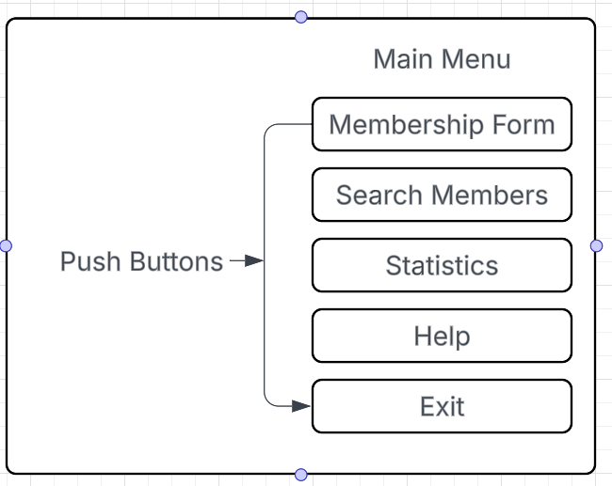
Main Menu

This menu Design is simple as it gives the user multiple choices.
The screen push buttons are used for selection on the menu. When a user clicks a button, it opens the corresponding option.

members wireframe.
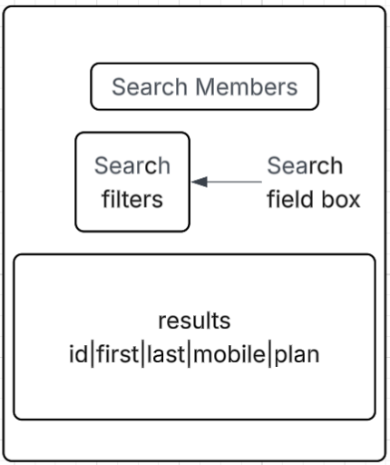

The search wireframe uses a simple filter section at the top allowing users to search by ID, last name. The search is centered to make it too easy to find the results table below the filters and uses column headings to help you see the data that is returned.

Statistics Screen wireframe
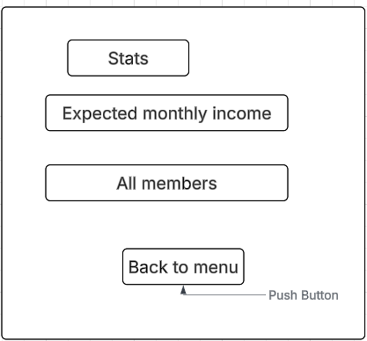
The statistics wireframe presents the information in a clear structured way. The summary of statistics appears first in the list followed by a table of the expected monthly income. This is then followed by a full membership list. This gives the users the opportunity to easily see the tables and data for more clarity. We have consistently used the same headings, grouping and spaces to make it easy to read and to support people with diverse needs.

Help Screen wireframe.

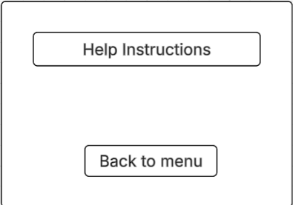
The help screen wireframe provides short, clear instructions this is accessible and easy to read. A single back to menu button ensures simple navigation.

Membership form Wireframe
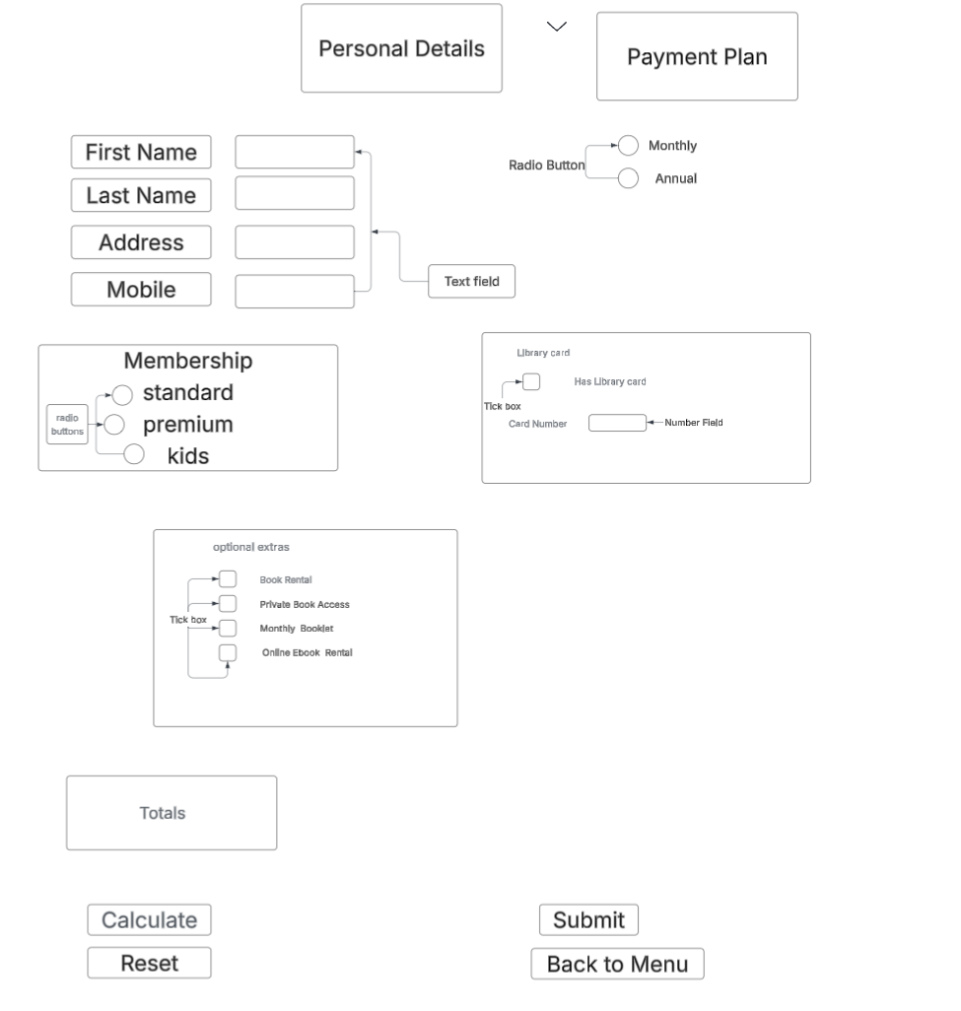

The membership form wireframe was designed to be simple and easy to use without any confusion. The layout follows clear top to bottom flow; it helps users understand what information is needed. Personal details are grouped together making it easy for users to enter their details.
Radio buttons are used for the membership types, for example standard, premium, kids. Radio buttons are used for the payments, monthly or annually.
Radio buttons are chosen because it can only give one choice to user that can be selected at a time. This is to prevent mistakes so that the users cannot select multiple options. This will help improve data accuracy.
Buttons are placed at the bottom of the form making the form intuitive for the first time users.
Overall, the wireframe is designed to be clear, predicable, and easy to navigate with clear error messages ensuring a positive user experience.

